**BUSINESS REQUIREMENTS DOCUMENT TEMPLATE**

PROJECT DETAILS

PROJECT NAME: **BooK Analytics**

CREATOR: **TEAM 2**

VERSION #: **V1**

1. EXECUTIVE SUMMARY SNAPSHOT

Our team plans to develop a data warehouse and visualization to access the current situation of the business and increase sales. This document is developed for both the developers and clients. Data warehouse will be developed in Snowflake, Data cleaning and transformation will be done and finally, the report will be generated in power BI where the users can see data in tabular form and graphs

1. PROJECT DESCRIPTION

Project purpose is to create a Data ware and report to visualize the current scenario of sales and understand the trend. The Data ware will be able to ingest the data, transform it and store it and the visualization created with Power BI will update to reflect the changes in the data. Data will be uploaded into the warehouse at daily basis as batch.

The visualization will answer the following question:

* What are the averages for purchases in each region?
* What form of payment is most common?
* Do our customers shop at work (most likely between 8:00 and 17:00) or at home?

**Data Mapping**

* To calculate the average by region, two-column regions and amount will be used.
* To analyse the form of payment, the Payment column will be used.
* To analyse, if the customer shop in the time of day, the time column will be used to determine the hour of the day and that time wil be compared if it within business hours(between 8 to 5)

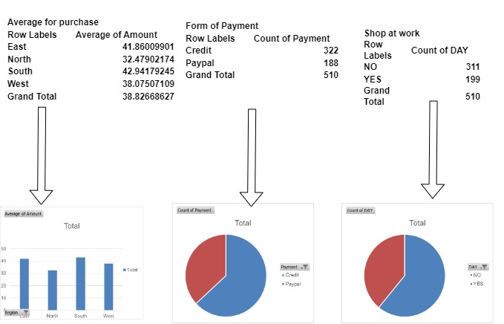

1. PROJECT SCOPE

Our team will create an EDW (Enterprise Data Warehouse) in Snowflake Cloud data warehouse instance and AWS S3 cloud storage with roles and security policies set up for establishing a connection as well as handling the PII data by following the industry standards.

Our team will also create power BI visualizations that will provide better data insights for Business decisions and help answer the business questions.

**IN-SCOPE ITEMS**

Item 1: Creating Snowflake Cloud Data warehouse Instance

Item 2: Creating AWS S3 cloud storage along with security policies and establishing the connection to Snowflake.

Item 3: Creating SnowPipe and Tasks for ETL pipeline

Item 4: Bar chart showing sales by region

Item 5: Pie Chart showing transactions by payment method

**OUT-OF-SCOPE ITEMS**

Item 1: Uploading the nightly batch file in S3 cloud storage.

Item 2:

Item 3:

Item 4:

1. BUSINESS DRIVERS

Business Driver 1: The amount of data is increasing on a daily basis and the storage of data is not possible with current infrastructure

Business Driver 2: Possibility of an increase in revenue if the pattern or trend in data is organized

Business Driver 3: Data cleaning and transformation with current infrastructure(excel) is not possible

1. PRESENT PROCESS

The data is collected in the excel sheet daily, and merging the daily data and cleaning it, transforming is not a long-term solution. On top of it visualization of data which is not cleaned transformed and formatted is not easy.

1. PROPOSED PROCESS

The picture depicts the data flow in the system.

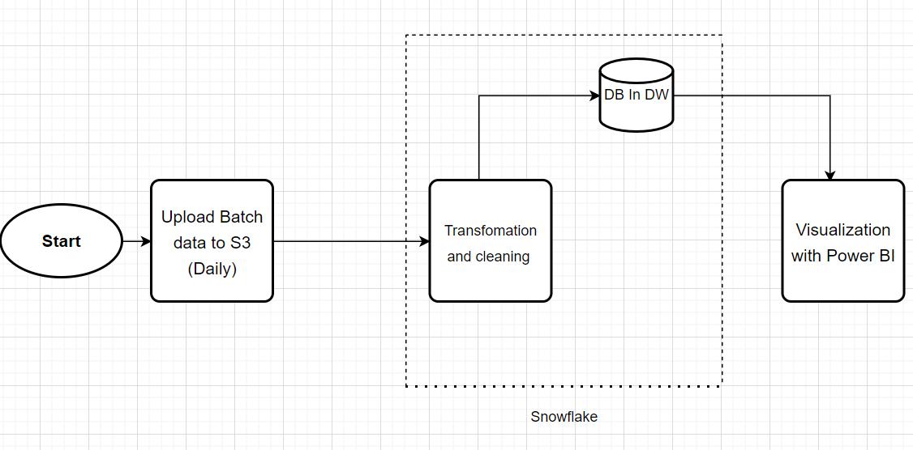

1. FUNCTIONAL REQUIREMENTS

User can see all the columns in Power BI

The Visuals has to be interactive (Display data when hovered)

Separate index has to be there for each Visual

User should be able to generate PDF from the given dashboard

**PRIORITY**

**STATUS : Value**

Immediate: Creating Data warehouse, Transfomation

High : Visualization with Power BI

Moderate: Automation

**DESCRIPTION**

The requirement is critical to the project’s success. Without fulfilling this requirement, the project is not possible.

The requirement is high priority re the project's success, but the project could still be implemented in a minimum viable product (MVP) scenario.

The requirement is important to the project’s success, as it provides value, but the project could still be implemented in an MVP scenario.

The requirement is of low priority, but the project’s success is not dependent upon it.

The requirement is out of the project’s scope and is included as a possible component of a prospective release and/or feature**.**

1. NON-FUNCTIONAL REQUIREMENTS

**ID REQUIREMENT**

1. An individual has to upload file to S3 on daily basis
2. The format of the file should be .csv
3. GLOSSARY

**TERM/ABBREVIATION**

ETL: Extract Transform and Load

Pipeline: Extract Transform and Load

PII : Personally Identifiable Information

EDW: Enterprise Data Warehouse

**EXPLANATION**

The scope of our project will include the following:

* Creating Snowflake Cloud Data warehouse Instance
* Creating AWS S3 cloud storage along with security policies and establishing the connection to Sno
* Creating SnowPipe and Tasks for ETL pipeline
* Creating PowerBI Users and setting up their account.
* Creating Useful Visualizations and reports for Business Insights.